EXPT NO:1 | Introduction to Python Libraries and Dataset Preprocessing
DATE: 21.01.2026 | Introduction to Python Libraries and Dataset Preprocessing

Name : Swasthika M

Roll no :24BAD121

PRE-LAB QUESTIONS:

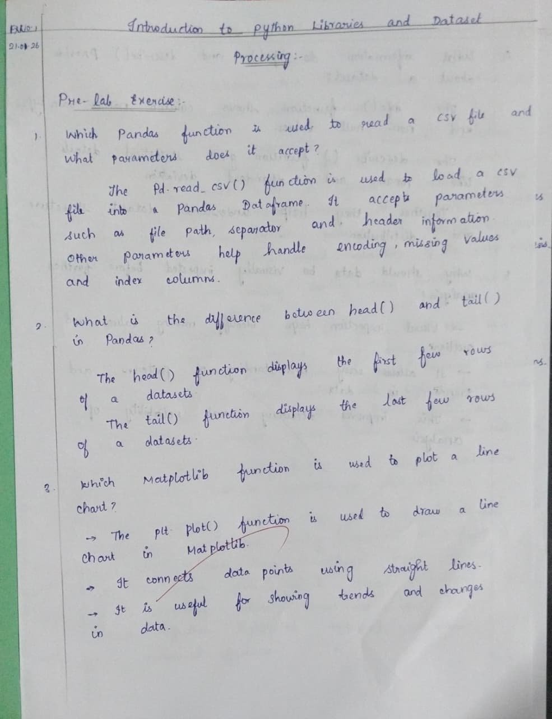

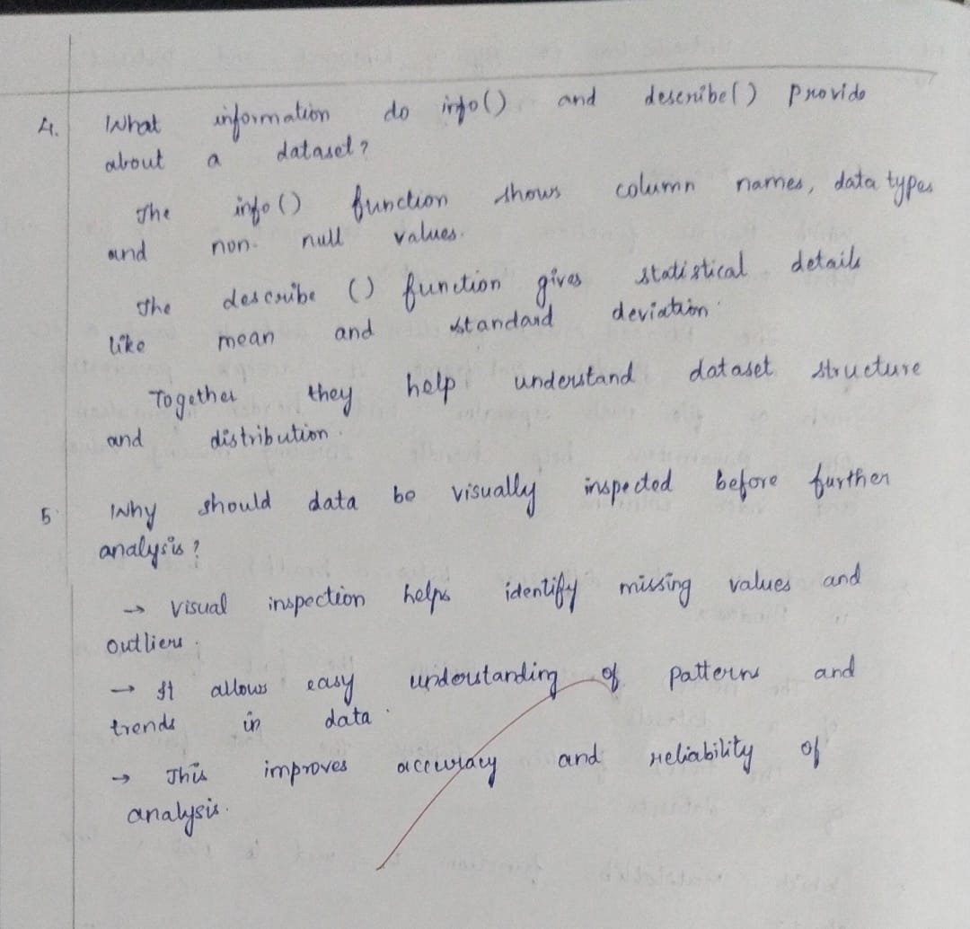
IN-LAB EXERCISE
OBJECTIVE: Explore and preprocess a dataset using Python.
SCENARIO 1: E-commerce Sales Data
Analyze a sample e-commerce dataset to understand product categories, sales trends, and missing information.
Dataset (Kaggle – Public):
https://www.kaggle.com/datasets/carrie1/ecommerce-data

IN-LAB TASKS:
- Import necessary Python libraries.
- Load the dataset into a Pandas DataFrame.
- Inspect dataset using head(), tail(), info(), and describe().
- Check for missing values.
- Visualize sales per product using bar and line charts.

Code:

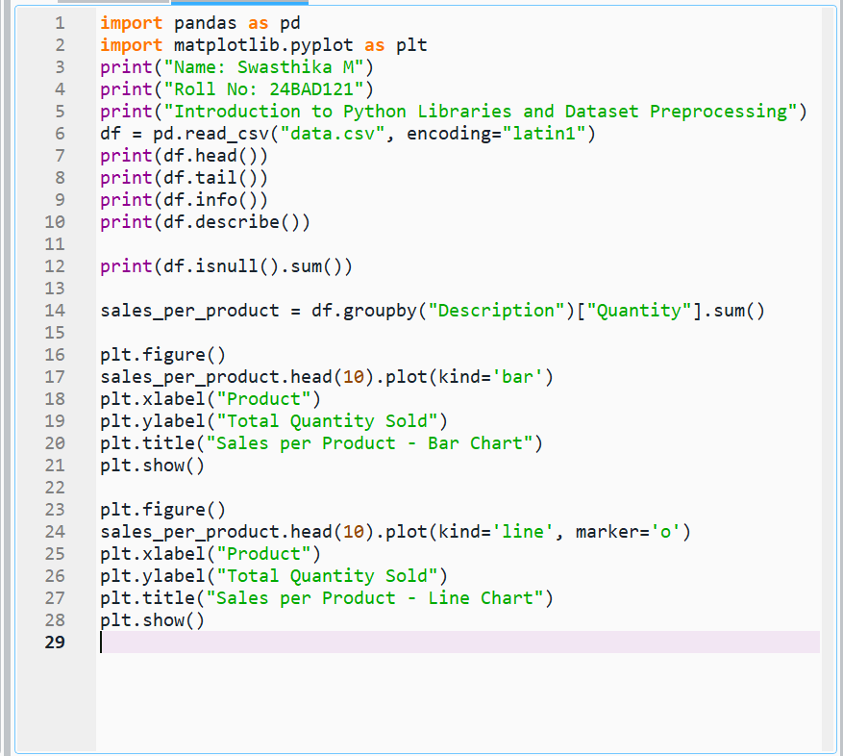

Output :

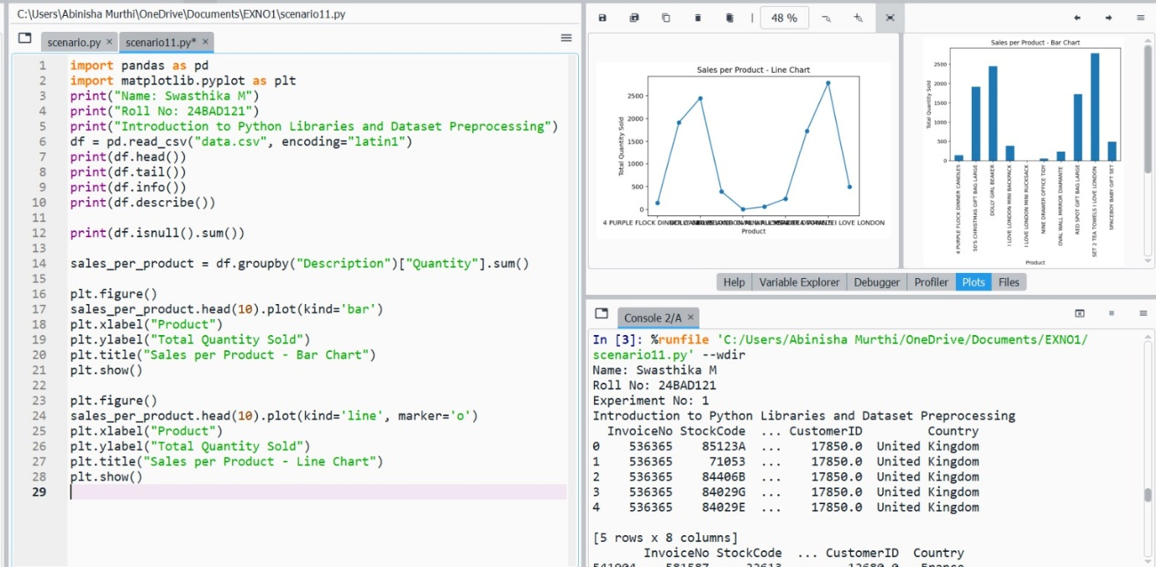

SCENARIO 2: Hospital Patient Records
Examine a patient dataset to identify missing health metrics and visualize distributions.
Dataset (Kaggle – Public):
https://www.kaggle.com/datasets/uciml/pima-indians-diabetes-database

IN-LAB TASKS:
- Load the dataset into Pandas.
- Explore data structure and missing values.
- Visualize glucose levels and age distribution using histograms and boxplots.
- Identify patterns in health metrics.

Code :

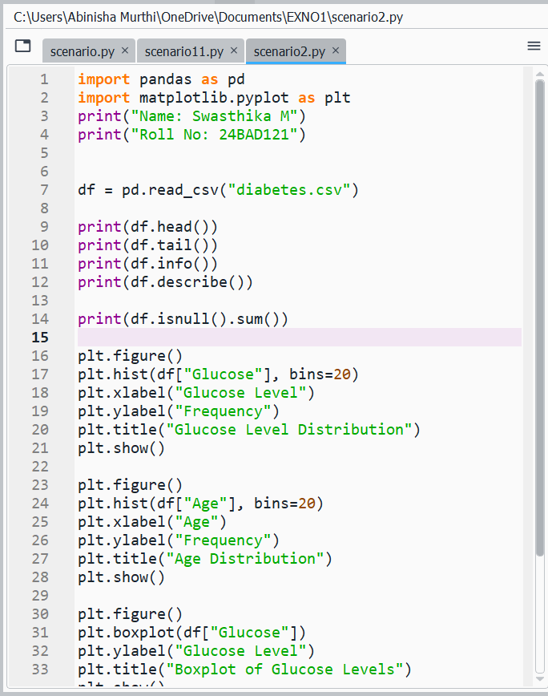

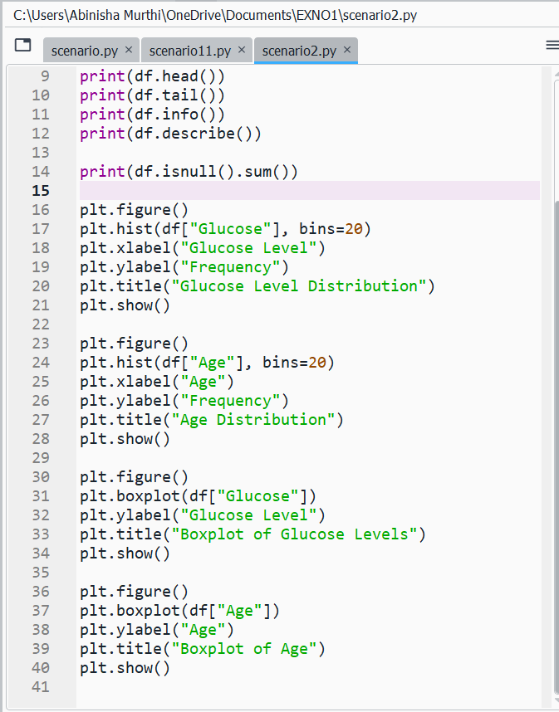

Output :
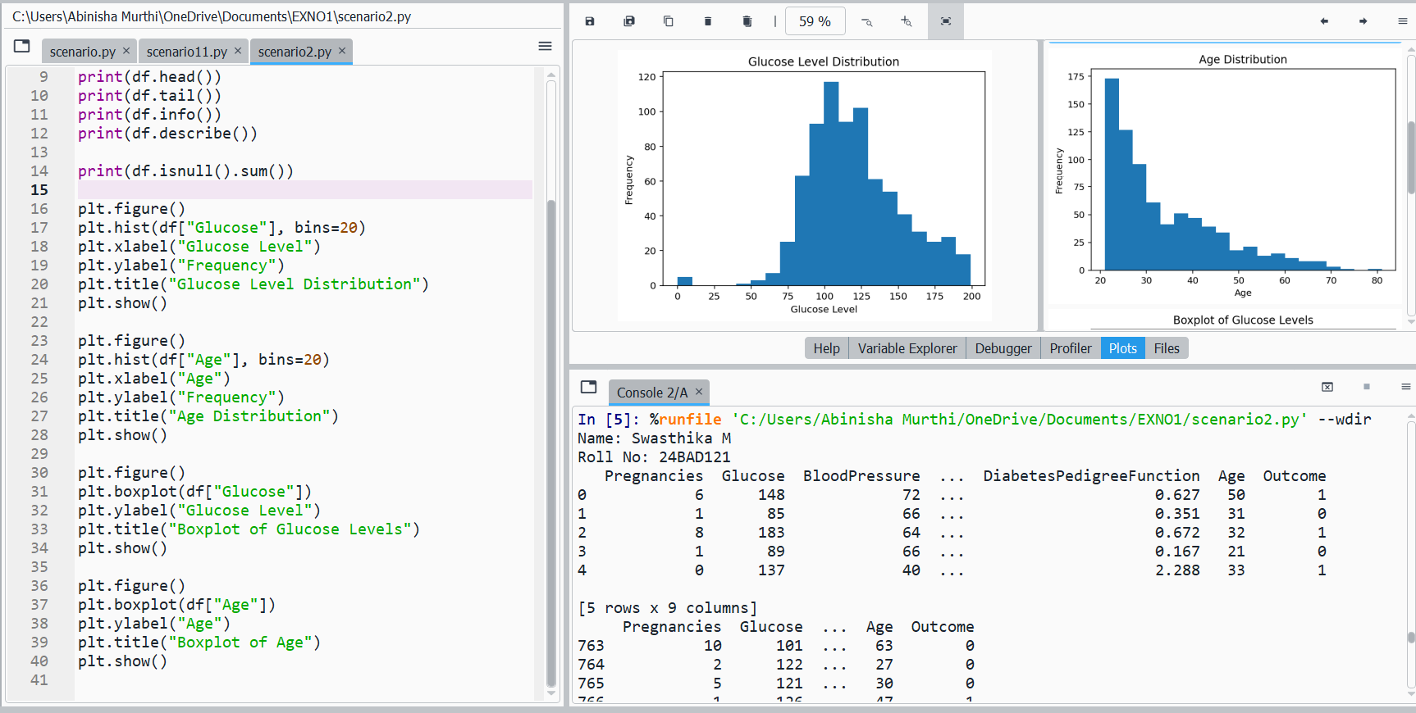

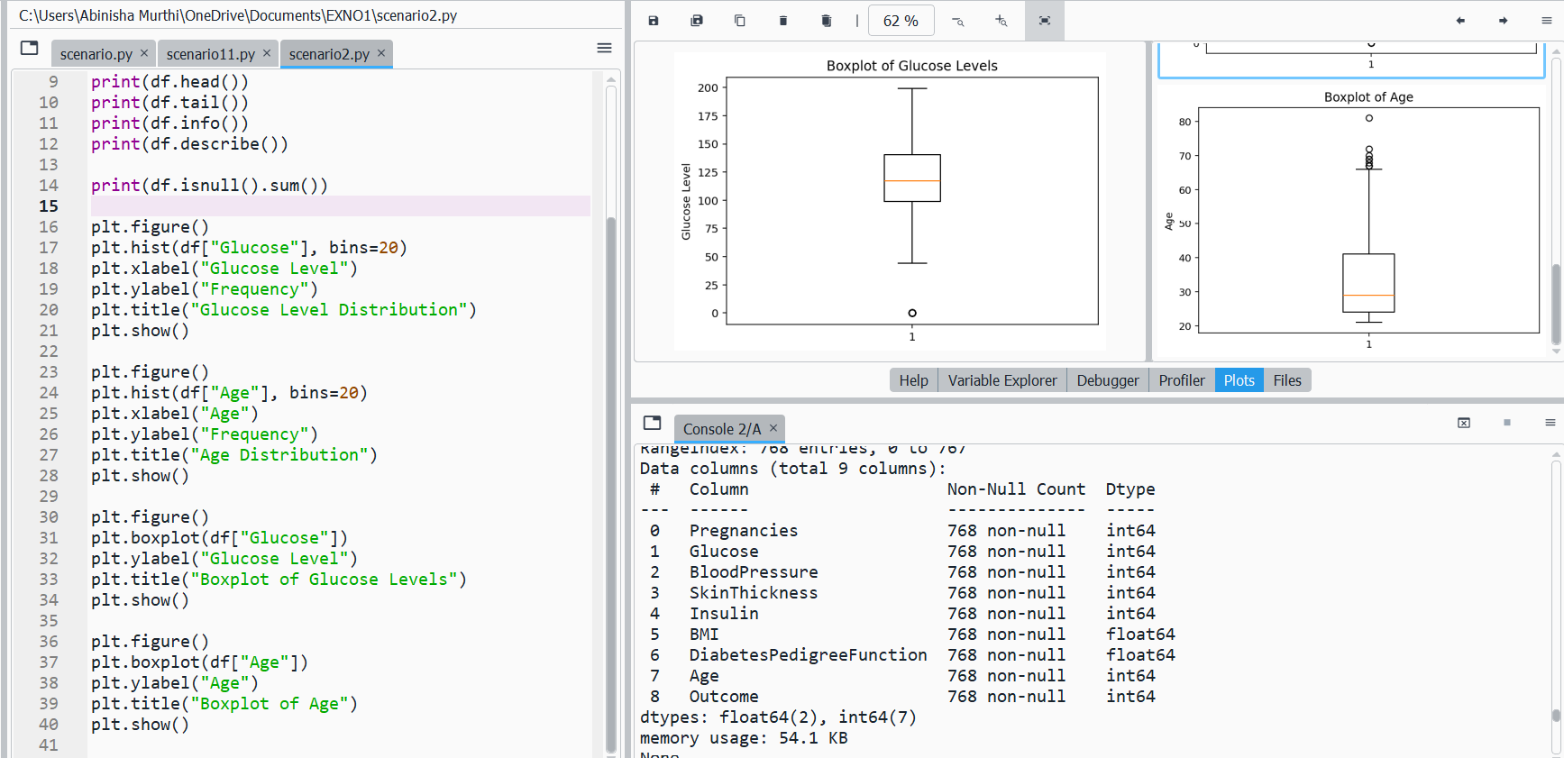

SCENARIO 3: Housing Dataset
Investigate a housing dataset for missing features and relationships between house attributes.
Dataset (Kaggle – Public):
https://www.kaggle.com/datasets/harishkumardatalab/housing-price-prediction

IN-LAB TASKS:
- Load the dataset and inspect columns.
- Detect and summarize missing values.
- Visualize correlations between numerical features using scatter plots and heatmaps.
- Interpret trends for price prediction.

Code :

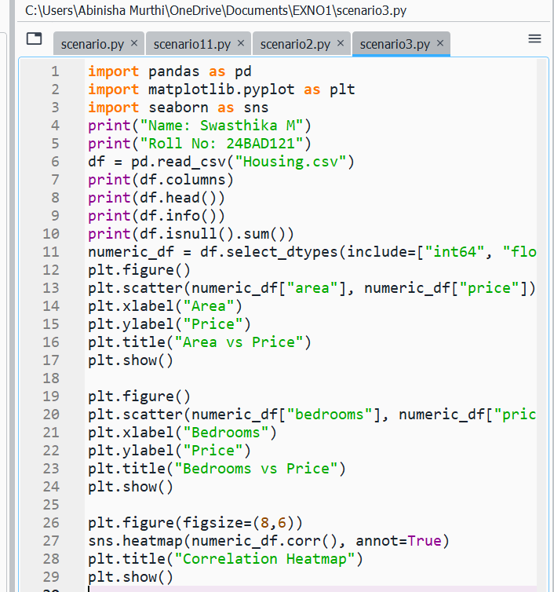

Output :

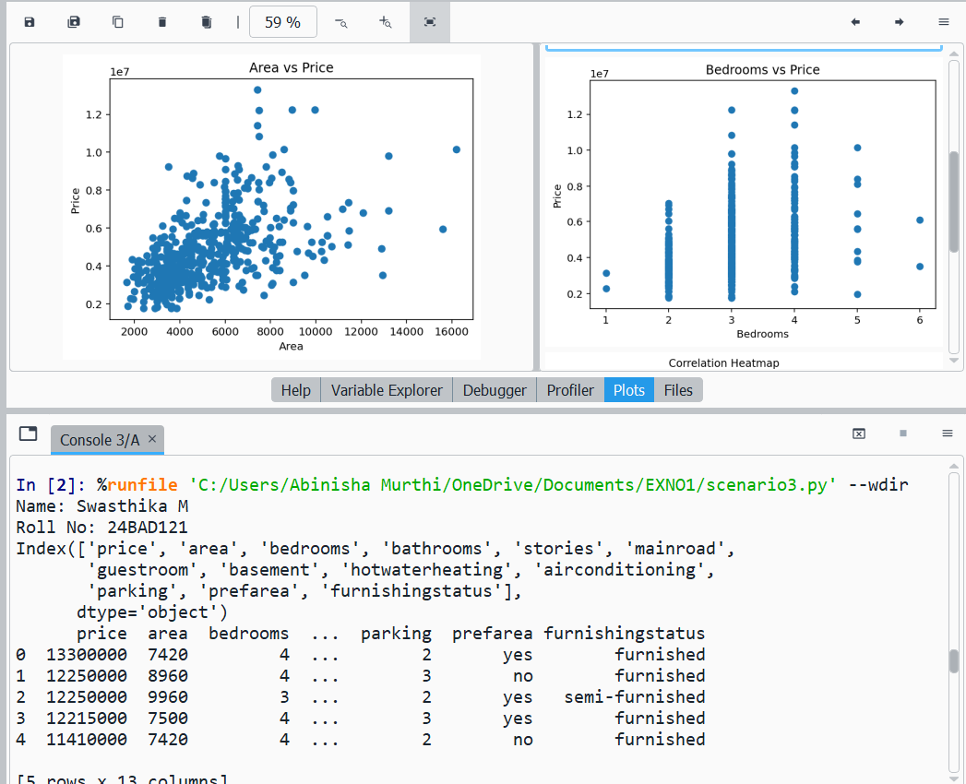

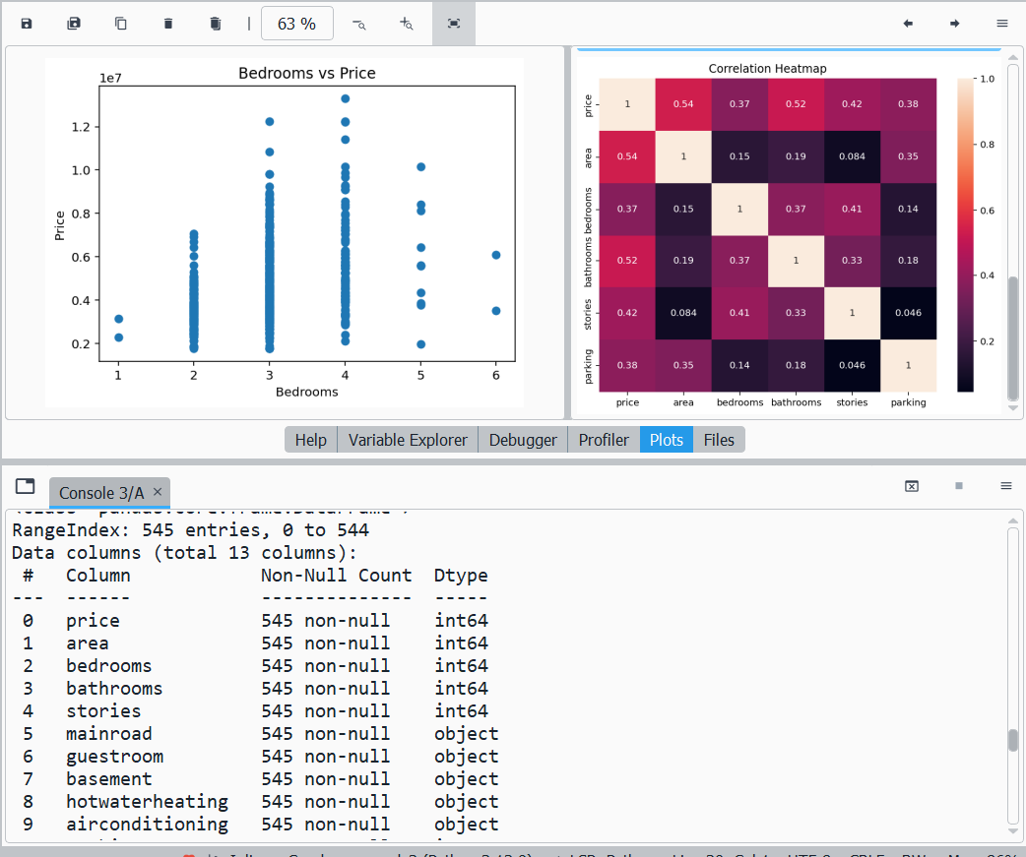

SCENARIO 4: Banking Customer Data
Analyze banking data to detect missing account information and understand customer demographics.
Dataset (Kaggle – Public):
https://www.kaggle.com/datasets/ajay1735/customer-personality-analysis
IN-LAB TASKS:
- Import dataset into Pandas.
- Examine structure, null values, and column types.
- Visualize age, income, and spending patterns using bar and box plots.
- Summarize insights from visualizations.

Code :
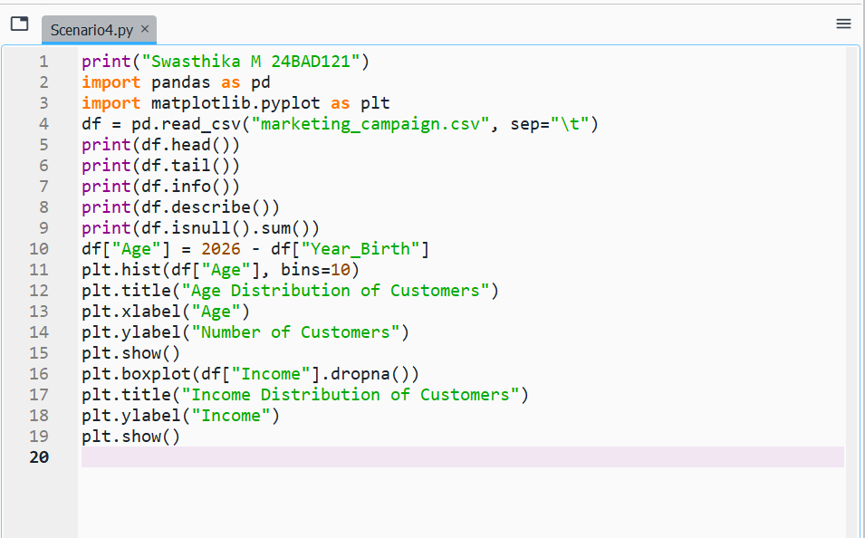

Output :

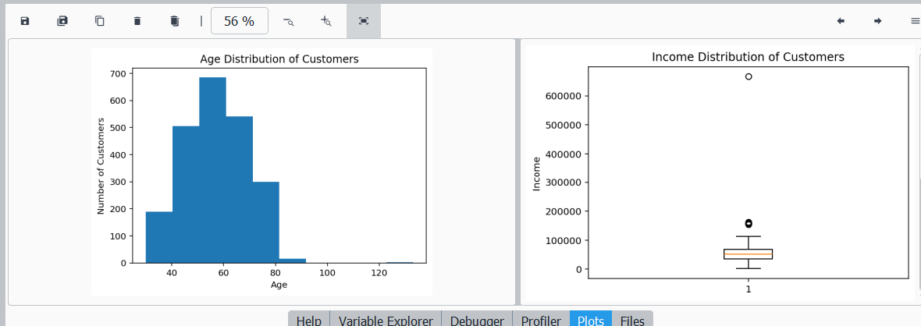

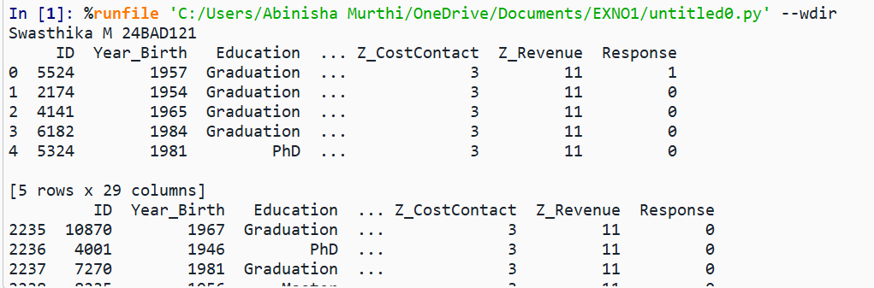

POST-LAB QUESTIONS

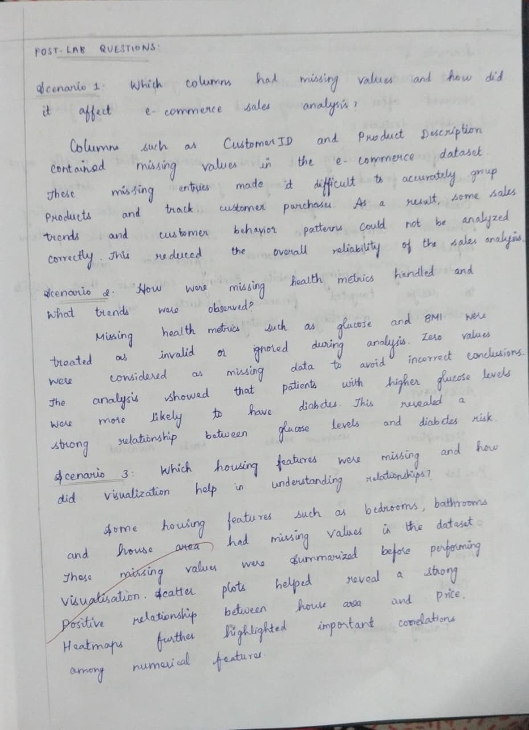

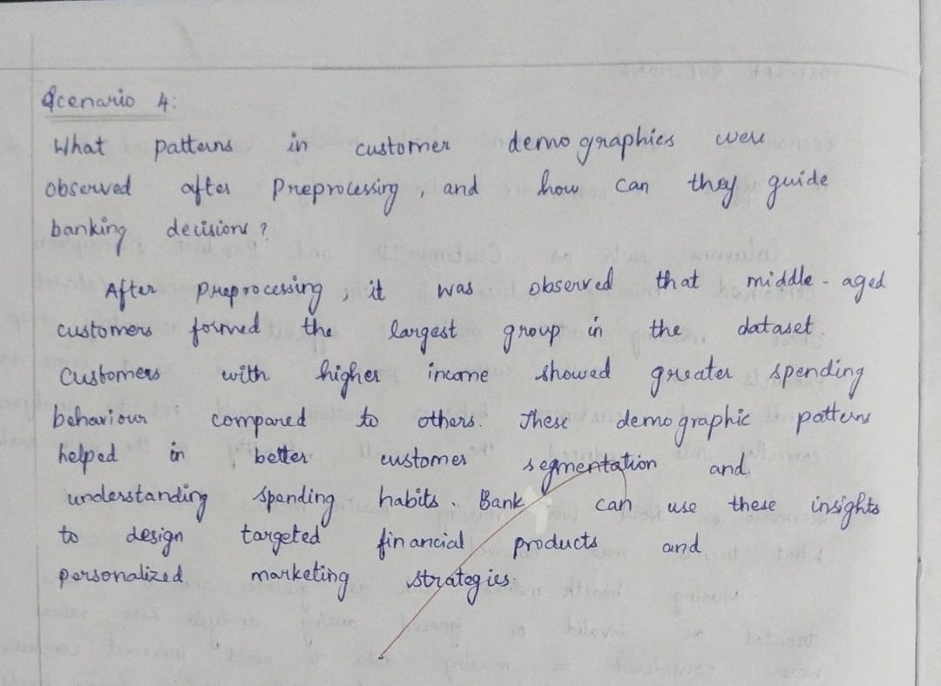

ASSESSMENT

